Retrieve and Rank – StopWords

Consultar StopWords

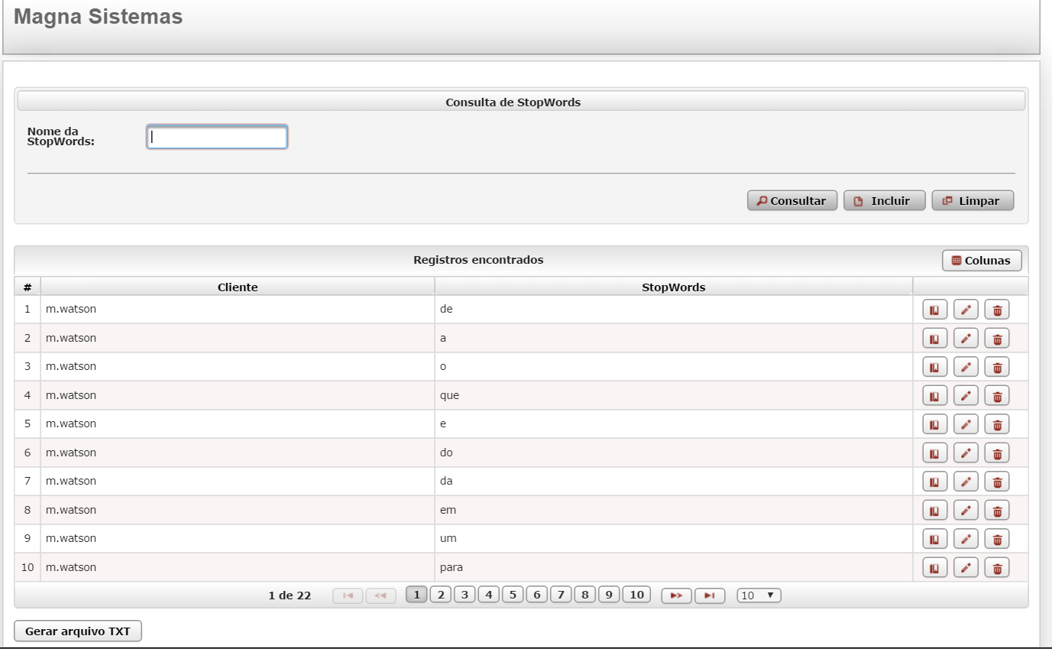

Detalhar StopWords

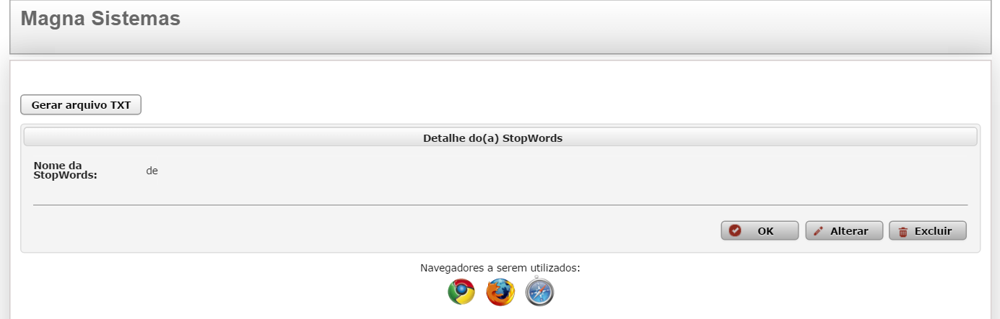

Alterar a StopWords

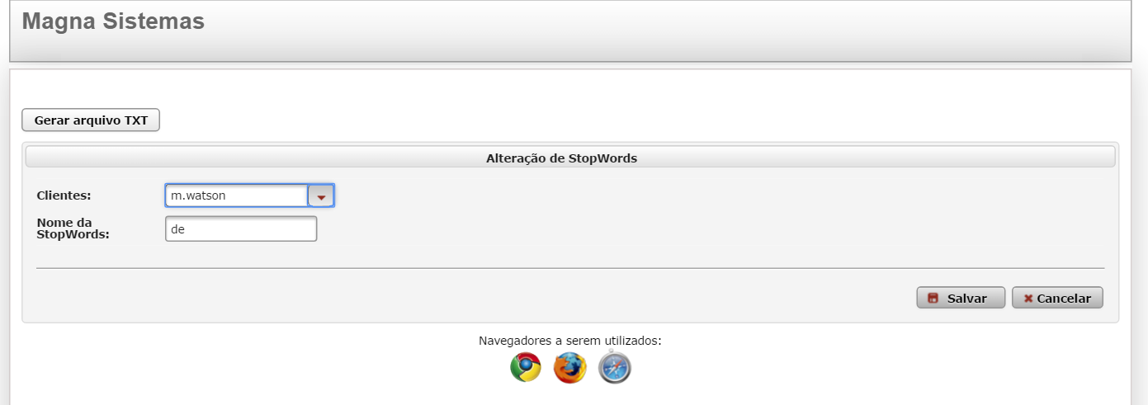

Incluir uma StopWords

